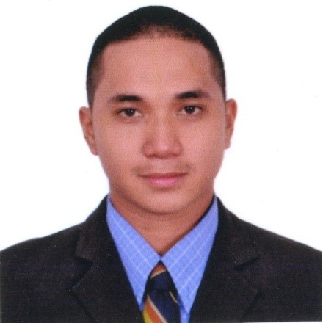 El john T. Cruz
Al Ali Qubaisi Bldg, Al Nahda Sharjah,U.A.E
Email add:eljohn.cruz@novaliches.sti.edu
Mobile No.: 0555 092 769
JOB TARGET:

IT Assistant/Sales/Customer Service Representative

Objective
To obtain a position that will enable me to use my educational skills and my knowledge that I’ve learned to my past Jobs, and able to walk into new environment, adapt new challenges, quick learner and goal oriented

WORKING EXPERIENCE

Gloaltronics, Inc
349 Ortigas Ave. Wack Wack Greenhills East, Mandaluyong City, Metro Manila, Philippines
Tel no. +63(2) 721 2878 +63 (2) 721 2585
May 2014 – April 2016

IT Staff
- Main responsibilities as IT staff are installing and configuring computer system, monitoring Lan/internet connection, trouble shoot computer hardware and software also the important task is to secure the files of every employees by having back up files and installing and scanning anti-virus

- Attend meeting with sales partner to discuss about technical information of Philips TV for Video walls, Electronic kiosk, Media player and LED Electronics Billboards and also responsible to upload Video Material for video wall and LED bill boards

- Giving assistance and support the existing client when they encounter technical problem regarding to our product

- Conduct minor technical training to give a high quality service to our client

Action Labs IT Services Corp/ SKY Cable
384-B E. Rodriguez Sr. Avenue Quezon City, Philippines
Tel, (02)575-1500
Fax Number: (02) 412-7245
August 2013 – May 2014

Field Support Engineer
- Main responsibilities is do field work to install internet connection to new application customer and assist all customer when they encounter problem like intermittent connection and no internet connection, no signal on cable TV, and scramble channel on TV

- Replacing Defective Digibox, modem router and connectors

- Act as Customer Support Representative to give assistance and support to customers via phone for basic trouble shooting

- Prepare weekly report

- Compiling daily accomplishment report, customer complain application and after reviewing the report must submitted to our main office for monitoring purpose to avoid some bad issue to our beloved customers

EDUCATIONAL BACKGROUND
Bachelor of Science in Information Technology (2008 – 2013),
STI COLLEGE NOVALICHES Diamond Ave. cor. Quirino Highway,
San Bartolome, Novaliches, Quezon City Philippines.

PERSONAL DATA
Civil Status : Single
Religion : Roman Catholic
Height : 5 ft. 6 inches
Nationality : Filipino
Visa Status : Tourist
Passport No. : EC6896442

